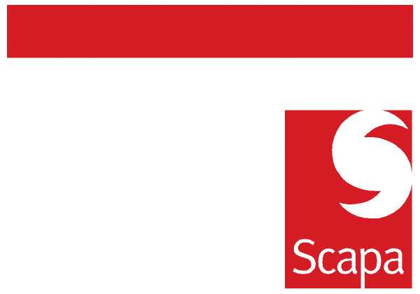

ANNOUNCEMENT

Mauro Dagna has decided to leave Scapa to pursue a new career.

Mauro has worked for Scapa Automotive and Industrial divisions for more than 13 years and in this time developed a wide network of positive personal relationships inside and outside of the company.

Over the coming weeks Mauro will support the transition of customer and business knowledge, and further announcements will be made regarding customer responsibility changes.

I’m sure you will join me in wishing Mauro all successes in his new career.

Barry Andrew Sergio Colonnelli

13 April 2010

